Waste Food Management and Donation System

**Sashitika R, Shanmugapriya S, Vishrudha N, Ms. Buvana M**

Department of Information Technology, Batchelor of Technology, Sri Shakthi Institute of Engineering and Technology (Autonomous) Coimbatore-641062

# ABSTRACT

Food donation to people in need is made easier with the help of the Waste Food Management and Donation System (WFMD), which attempts to solve the serious problem of food waste. Food contributors, including eateries, supermarkets, and private citizens, can connect with food banks and nonprofit organisations through this system's user-friendly website. In order to expedite food donation and minimise food waste, the WFMD system integrates a number of essential functions. Contributors of surplus food can enter information into the system regarding the kind, quantity, and expiration date of the food they would like to contribute. A user-friendly interface then makes this data available to food banks and recognised charitable organisations. The WFMD system uses sophisticated algorithms to connect surplus food donations with recipient organisations' unique needs and specifications. The system makes sure that donated food is distributed effectively by looking at things like location, dietary preferences, and storage capacity. Thirdly, the system has scheduling and logistics management features that make it easier to arrange for the prompt pickup and delivery of donated food. While recipient organisations handle logistics and make transportation arrangements, donors can designate preferred pickup times and locations.

**INTRODUCTION**

Food waste is a major worldwide problem with serious negative effects on the environment, the economy, and society. Food insecurity is still a serious issue, though, particularly for vulnerable groups like homeless people and orphanages. In order to effectively manage food surplus and guarantee its allocation to those in need, creative solutions are needed to address these interconnected difficulties. With an emphasis on supplying food to street orphanages, a waste food management and donation system has been created to close the gap between food waste and food insecurity. By establishing a connection between food givers, such as grocery stores, restaurants, and houses, and beneficiaries in street orphanages, this approach makes sure that excess food is given to those who really need it.

**Objective:**

1. The Waste food management and donation system put policies in place to reduce food waste from production to consumption at every stage of the supply chain.
2. The system promotes and assist the donation of extra food to food banks and humanitarian organizations and it easier for people and businesses to safely and effectively contribute food by streamlining the procedure.
3. The Donation system create procedures to guarantee that food given satisfies all health and safety requirements and to avoid infection, teach donors how to handle and store food properly.
4. Increased availability of wholesome food for marginalized and susceptible groups that boost collaborations with neighborhood groups, shelters, and charity to efficiently distribute food donations.
5. It encourages the composting and recycling of food that is no longer edible to lessen the negative effects of food waste on the environment and improved waste management techniques can reduce greenhouse gas emissions linked to food waste.

# LITERATURE SURVEY

A third of all food produced is lost or discarded, making up around 1.3 billion tonnes of food loss yearly, making food waste a serious global problem. Reducing food waste's negative effects on the environment, the economy, and society requires efficient administration and donation programmes.

.

It involves the avoidance, recovery, and recycling of food waste are just a few of the solutions discussed in current research. According to Aschemann-Witzel et al. (2017), prevention aims to cut waste at its source by enhancing supply chain efficiency, educating consumers, and using better farming techniques. Food banks and donation programmes are used in recovery to provide extra food to individuals in need. This practice is encouraged by laws like as the Good Samaritan Food Donation Act in the United States.

By examining various sources such as research articles, journals, and books, a literature survey can provide valuable insights into the current landscape of Waste food management and Donation system and guide future research and development in this field. By conducting a thorough literature survey, we can gain a better understanding of the current landscape and pave the way for future research and development of effective and user-friendly Waste food management and Donation system.

# METHODOLOGY

Initially, a thorough study of the literature was done, which included academic papers, reports from global agencies like the FAO and UNEP, and pertinent official publications. The goal of this review was to give readers a comprehensive grasp of the extent of food waste worldwide, its effects on the environment and the economy, and the different approaches to managing it.  
  
Second, case studies from multiple nations were examined to pinpoint effective methods and typical difficulties in the administration of food waste and donation schemes. Because these case studies were chosen to reflect a range of socioeconomic backgrounds and geographic locations, it is possible to compare various strategies and results.

Thirdly, these sources were the source of quantitative data that was gathered to evaluate the effects of different initiatives on reducing food waste. Analysing food production, waste, donation, and the ensuing economic and

environmental benefits of methods put into practice were among the statistics that were examined.

Lastly, in order to determine best practices and create policy recommendations, the gathered information and insights were combined. This required analysing the results of case studies, quantitative data, qualitative interviews, and literature reviews in order to get thorough conclusions regarding practical food waste management and donation techniques.

**Existing system:**

The current Waste food management and Donation system for managing and donating food waste is complex and involves coordinated efforts from several industries. Food banks and nonprofit organizations are essential in rescuing excess food from supermarkets, farms, and eateries and redistributing it to food pantries and shelters for the underprivileged. In order to avoid throwing away excess inventory, a lot of supermarkets and grocery stores take part in donation programs and provide it to charitable organizations. Government initiatives like the Good Samaritan Food Donation Act give food donors legal safeguards, enabling companies to donate excess food without worrying about legal repercussions. Initiatives for consumer education increase knowledge about food waste and offer advice on cutting waste at home. The effective redistribution of surplus is made possible by technological advancements like internet platforms and smartphone apps.

**Disadvantages:**

* It can be difficult and expensive to plan for the gathering, storing, and redistributing of excess food, especially when it comes to perishable goods with limited shelf life.
* Ensuring the food supplied is safe is a big deal because poor handling or storage can cause contamination and foodborne illnesses that could hurt the beneficiaries.
* Inequalities in access continue to exist despite efforts to disperse excess food, with some areas or groups of people not receiving enough assistance, making food insecurity in underprivileged areas worse.
* There may be inefficiencies and gaps in service delivery during times of great need or surplus if the current system is unable to adapt to changes in food surplus and demand.

**Proposed system:**

Maximising efficiency, equality, and sustainability while addressing the shortcomings of the current system is the goal of the suggested waste food management and donation system. Simplified distribution and logistics systems to make it easier to gather and repurpose excess food are among its many essential elements. The technology in this system will allow for the real-time connection between food donors and beneficiaries, facilitating a more rapid and effective distribution of resources. Examples of this technology include mobile applications and centralised web platforms. To further guarantee the calibre and security of donated food, extensive food safety procedures and educational initiatives will be put in place. Prioritising underprivileged groups and areas with the most need will help ensure equitable distribution. Data-driven methods will be used to identify areas that need more assistance.

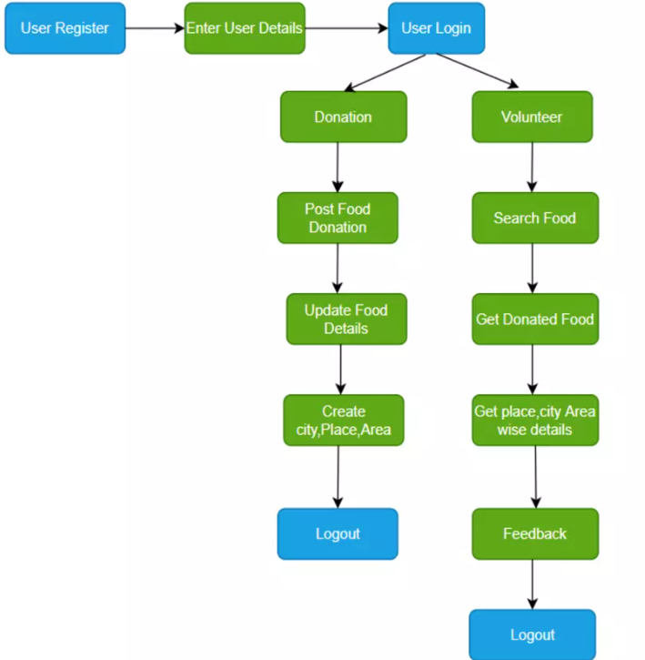

**SYSTEM REQUIREMENTS**

**Hardware Requirements:**

* + Devices.
  + Intel Core i5 processor or equivalent.
  + Minimum 2 GB RAM for smooth operation.
  + 100 MB of free storage space for the app and data.
  + Internet Connection.

# Software Requirements:

* + HTML.
  + CSS.
  + JAVASCRIPT.
  + PHP.
  + BOOTSTRAP.
  + XAMPP

**Module Description**

1. VOLUNTEER AND NGO SIGNUP:

* Signup is an action to register themselves for a new account that consist of username and password.

1. VOLUNTEER AND NGO LOGIN:

* A login generally requires the user to enter to two piece of information first a username and a password.

1. DONATING FOOD:

* The volunteer donates the food and this donation consists of quantity of food, meal type, food name , address.

1. DELIVERING THE FOOD:

* The NGO delivers the food wherever food requires.

**LOGIN PAGE**

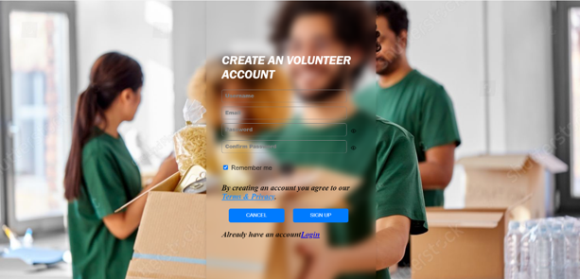

**SIGNUP PAGE**

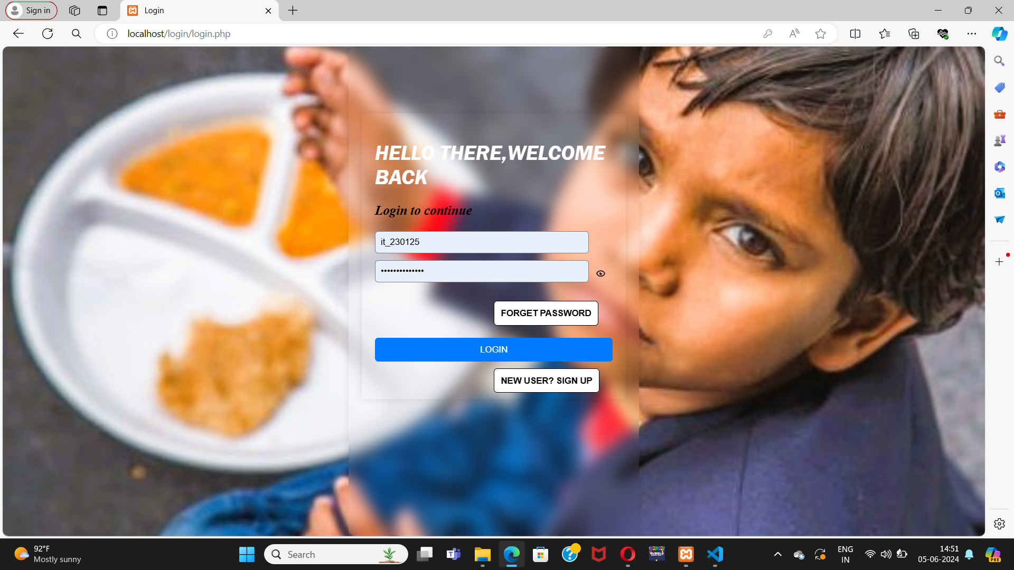

**DONATING FOOD PANEL**

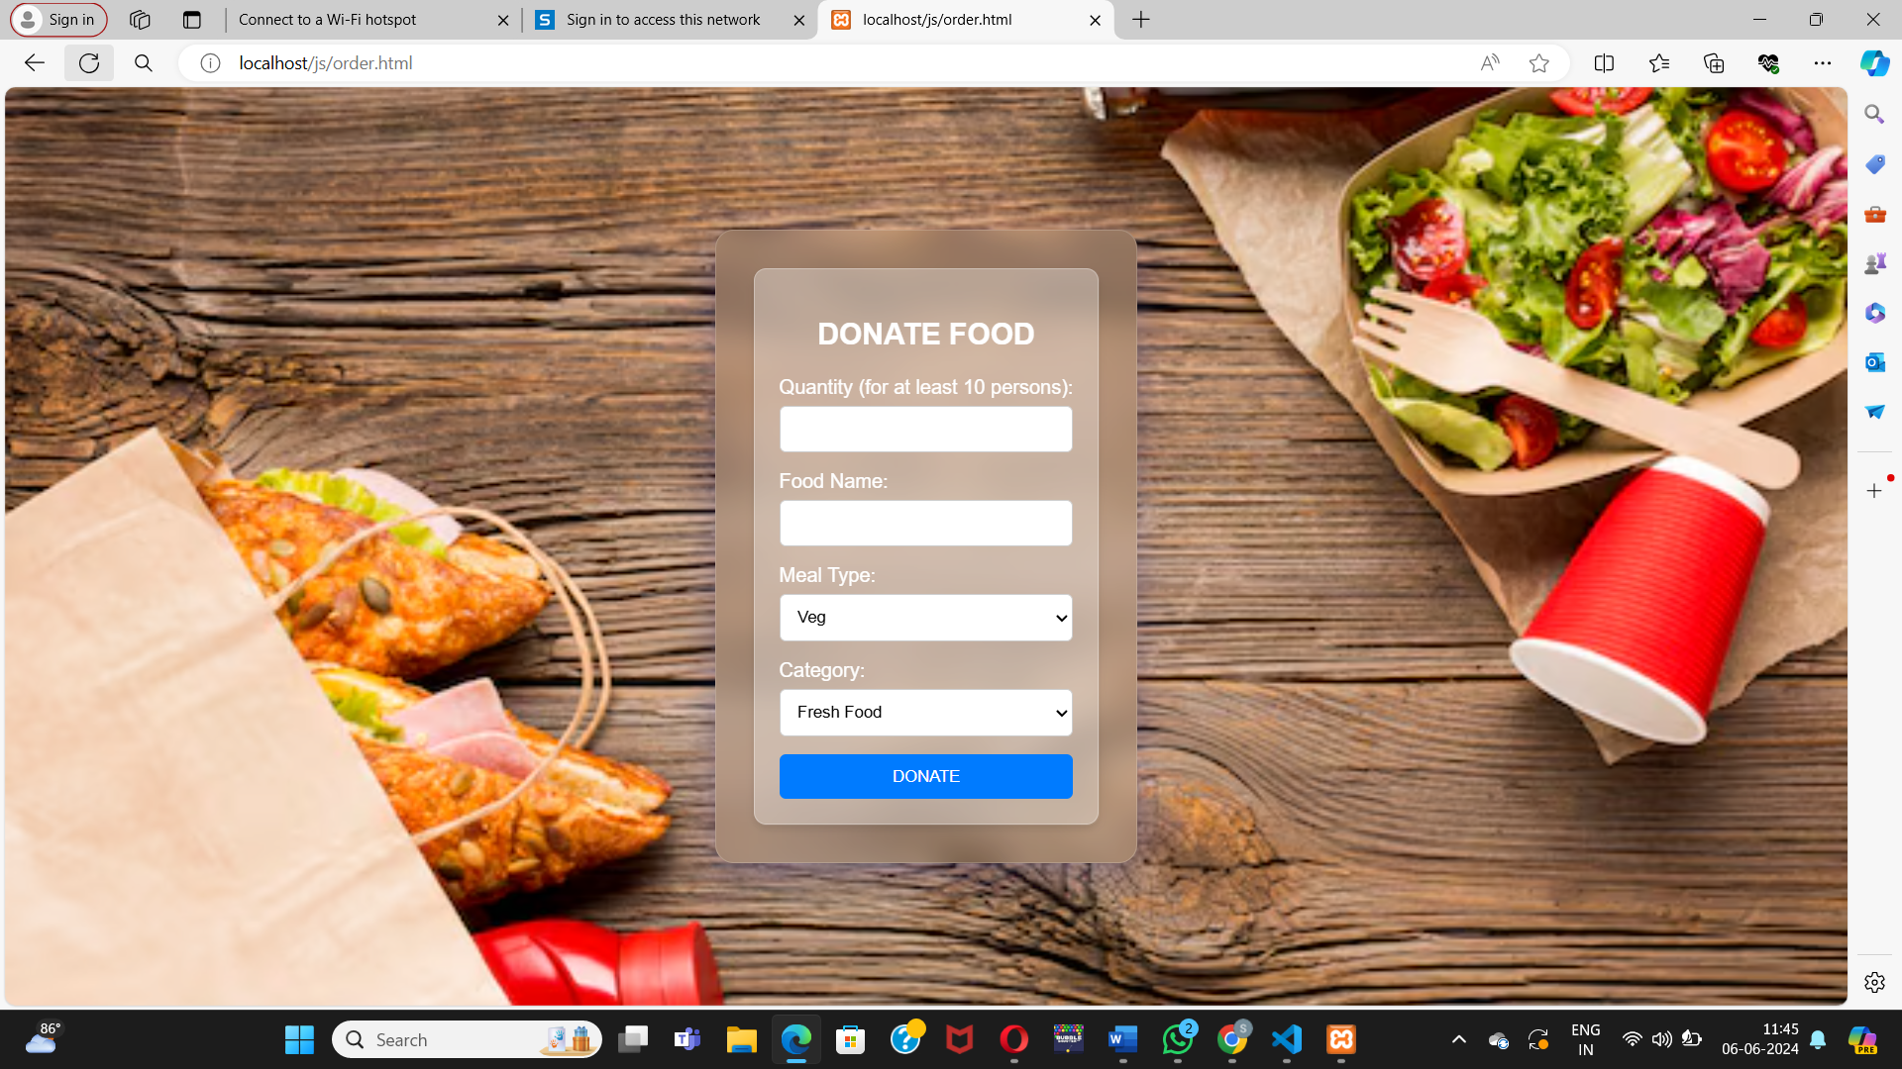

**DONATED FOOD LIST**

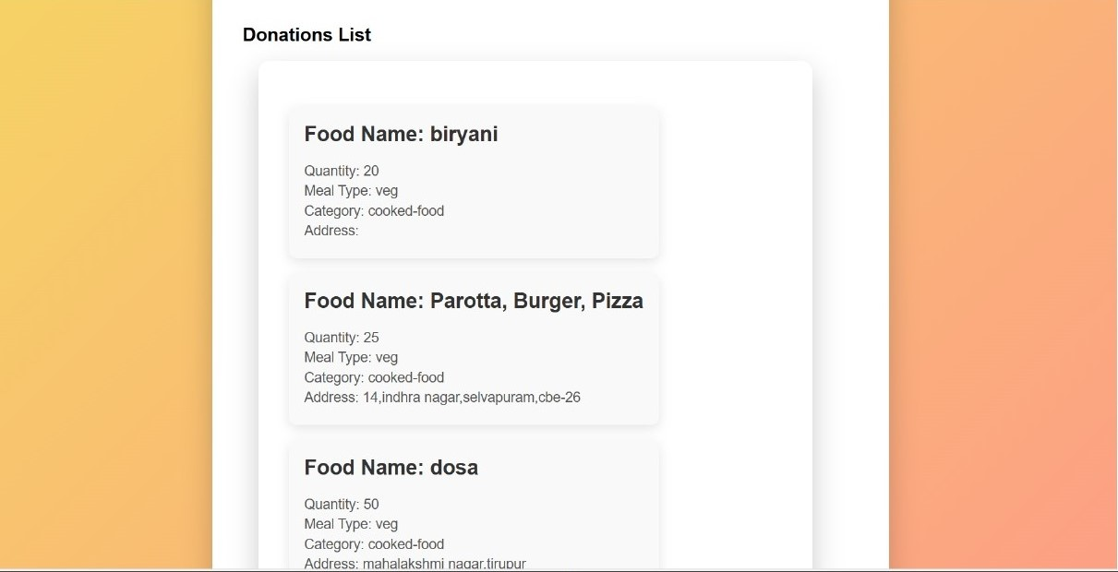

# CONCLUSION

In conclusion, the development of a Waste food management system and donation system efforts to tackle food waste and food insecurity worldwide must include the waste food management and donation programmes. Though praiseworthy for its efforts, the current system has some drawbacks, including difficult logistics, worries about food safety, and unequal distribution. It also embodies important qualities, such as the impact of government policies, the commitment of corporations, and the dedication of non-profit organisations. It is essential to address the flaws in the current system while building on these positives going future. This entails optimising food safety procedures, fostering fair distribution of excess food, and putting in place simplified logistics. Furthermore, in order to address the underlying causes of food waste and establish a more efficient and sustainable system, prevention and reduction methods must be given top priority.   
  
  
  
  
 **REFERENCES**

[1] Vana shreeMhatre1, Shweta Chavan2, Snehal Gamare3, Prof. Varsha Salunkhe4 [1,2,3] (Computer Engineering), Atharva College of egn, Mumbai.

[2] K. Harika, K. Swetha, Sruthi Koneru Department of Computer Science and Engineering, Stanley College of Engineering and Technology for Women, Telangana, India.

[3] Review in Food Wastage Reduction Through Donation Application. June 2020 DOI:10.17148/IJIREEICE.2020.8611. Authors: Sankar Vt K.S.R. College of Arts and Science.

[4] A Review of Empirical Applications on Food Waste Prevention & Management; March 2018Project: Coach AI: A Conversational-UI Assisted Ecoaching platform For Health & Wellbeing Authors: Ahmed Fadhil Universita degli Studi di Trento, Fondazione Bruno Kessler.

[5] Zero Hunger: Smart Food Donation System using IoT Juhi Patil, Gayatri More, Pooja Mahale, Nikita Harale and Vijaylaxmi Bittal Department of Computer Science and Engineering SVKM’s Institute of Technology Dhule, MH, India.

[6] Food Waste Loss and Donation U.S. Environmental Protection Agency Office of Resource Conservation and Recovery May 2013.

[7] Mrigank Mathur, Ishan Srivastava, Vaishnavi Rai, Aahar Food donation App International Journal of Scientific Research & Engineering Trends May-June2021.

[8] R. Adline Freeda1, M.S. Sahlin Ahamed2,” Mobile Application for Excess Food Donation and Analysis”, April 2018, International Journal Of Innovation Research In Science Engineering & technology (IJIESET).

[9] Komal Mandal, Swati Jadhav, Kruti Lakhani, Food Wastage Reduction through Donation using Modern Technological Approach: Helping Hands International Journal of Advanced Research in Computer Engineering & Technology (IJARCET), April 2016.

[10] Ayesha Anzer, Hadeel A. Tabaza, and Wedad Ahmed, Hassan Hajjdiab, A Food Wastage Reduction Mobile Application 2018 6th International Conference on Future Internet of Things and Cloud Workshops.